SpendWise
A Simple Backend Learning Project
Ideation Phase · Define the Problem Statements

Date | 08 March 2026
Project Name | SpendWise
Document Type | Ideation Phase — Define the Problem Statements
Team ID | SWTID-2026-1005

Overview
A customer problem statement captures the user's point of view — who they are, what they want to achieve, what is blocking them, why the blocker exists, and how it makes them feel. In the SpendWise project it focuses on the needs of beginner backend students who want to learn Node.js, Express, MongoDB, and JWT in a practical, structured way. Defining these statements clearly ensures the solution stays focused, empathetic, and genuinely useful.

1 | Customer Problem Statement Template  Understand the five-part framework used to define every problem statement.

Why this framework matters?
It shifts focus from features to feelings — building empathy before building code.
It prevents scope creep by tying every design decision back to a specific user need.
It provides a shared vocabulary for the entire team during the ideation phase.
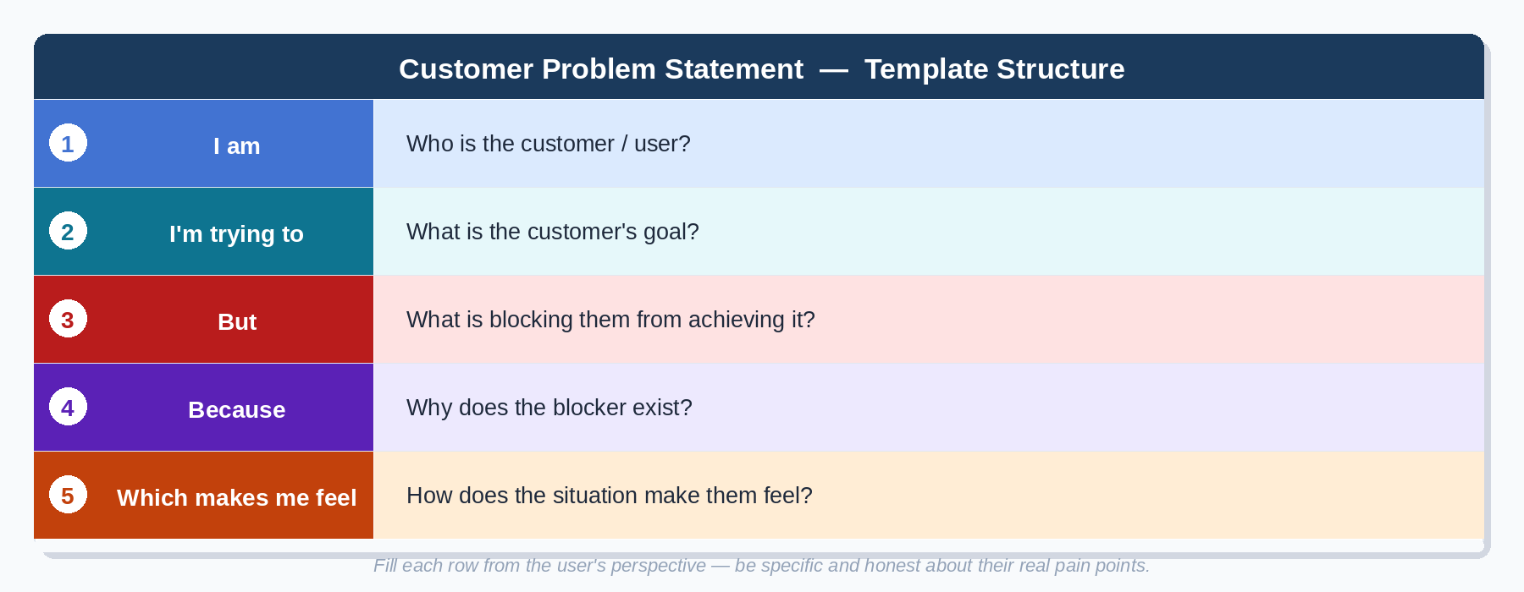

2 | Worked Example — PS-1  See how the template is applied to the first SpendWise problem statement.

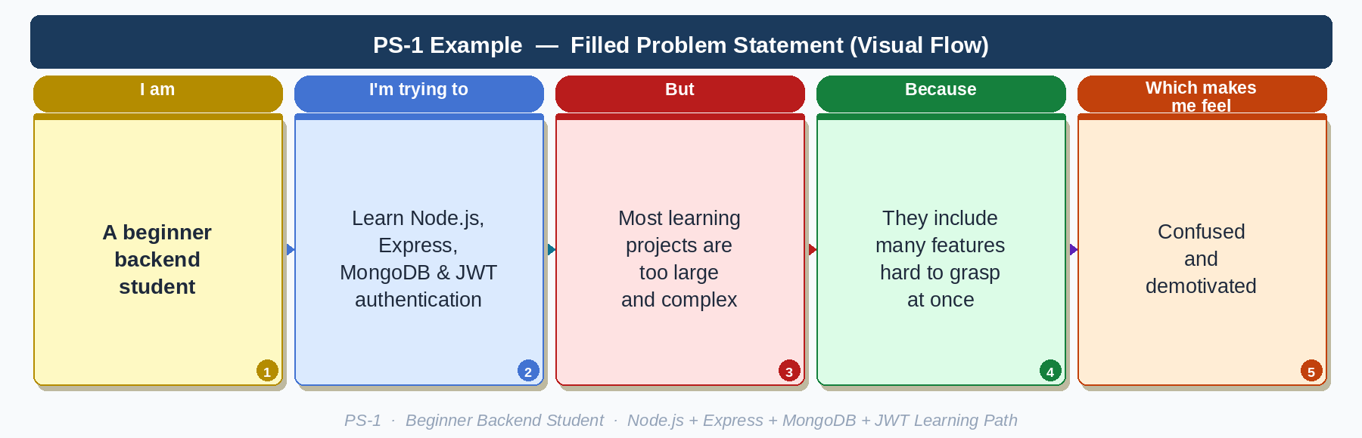
Writing Tip 💡
Keep each response concise — one clear sentence per field is enough.
The 'Because' field is the most valuable: it uncovers root causes, not just symptoms.
The 'Which makes me feel' field adds emotional context that justifies why solving these matters.

3 | All Problem Statements — SpendWise  Four defined problem statements covering the full range of beginner backend learner pain points.

PS | I am (Customer) | I'm trying to | But | Because | Which makes me feel
PS-1 | A beginner backend student | Learn Node.js, Express, MongoDB, and JWT authentication | Most learning projects are too large and complex | They include many features that are hard to understand at once | Confused and demotivated
PS-2 | A college student | Build a simple backend project for practice and submission | No clear example exists focused only on CRUD and authentication | Tutorials often jump to advanced topics without explaining the basics | Unsure about my understanding
PS-3 | A beginner developer | Connect JWT authentication with MongoDB and APIs | Errors keep appearing in tokens or database connection | The flow between login, token generation, and protected routes is not clear | Frustrated and stuck
PS-4 | A student preparing for viva or interviews | Explain CRUD operations and JWT authentication with a live project | No simple end-to-end backend example is available | Most available projects are either too basic or too advanced | Nervous and underprepared

Detailed Problem Statement Breakdown
Each problem statement is presented in full below for reference during implementation planning.

PS-1 — Beginner Backend Student
I am a beginner backend student.
I'm trying to learn Node.js, Express, MongoDB, and JWT authentication.
But most learning projects are too large and complex.
Because they include many features that are hard to understand all at once.
Which makes me feel: Confused and demotivated.

PS-2 — College Student
I am a college student.
I'm trying to build a simple backend project for practice and submission.
But I don't find a clear example focused only on CRUD and authentication.
Because tutorials often jump to advanced topics without explaining the basics.
Which makes me feel: Unsure about my understanding.

PS-3 — Beginner Developer
I am a beginner developer.
I'm trying to connect JWT authentication with MongoDB and APIs.
But I keep getting errors in tokens or database connection.
Because the flow between login, token generation, and protected routes is not clear.
Which makes me feel: Frustrated and stuck.

PS-4 — Student Preparing for Viva / Interviews
I am a student preparing for viva or interviews.
I'm trying to explain CRUD operations and JWT authentication with a project.
But I don't have a simple, complete end-to-end backend example.
Because most available projects are either too basic or too advanced.
Which makes me feel: Nervous and underprepared.

Key Insights from the Problem Statements
Pain Point Theme | Appears In
Complexity overload in learning resources | PS-1, PS-4
Lack of focused beginner-friendly CRUD examples | PS-2
JWT + MongoDB integration confusion | PS-1, PS-3
Unclear flow between auth, tokens, and routes | PS-3
Need for end-to-end demonstrable project | PS-4
Tutorials skipping foundational explanations | PS-2

How SpendWise Addresses These Pain Points
Focused scope: Only CRUD, JWT, and MongoDB — nothing extra.
Clear folder structure: routes, controllers, models — easy to navigate and explain.
Step-by-step auth flow: Register, login, JWT generation, and protected routes in sequence.
Postman collection included: Every endpoint is testable without writing extra client code.
Portfolio-ready: Simple enough to explain confidently in a viva or interview setting.

